Title of the research [14pt Times New Roman, bold, centered]

First Middle LAST¹, Naoto KAMATA² & First Middle LAST³ [12pt Times New Roman, centered]

¹Author(s) affiliation, COUNTRY, e-mail [12pt Times New Roman, centered]
²The University of Tokyo Chichibu Forests, JAPAN, kamatana@uf.a.u-tokyo.abc.jp
³Author(s) affiliation, COUNTRY, e-mail [12pt Times New Roman, centered]

Introduction [Heading Level 1: 12pt Times New Roman, bold, left justified]
For those who present their research at the 5th Symposium of Asian University Forest Consortium held in September 2012, Japan, we would like you to submit your extended abstract for proceeding publication of the symposium. For your preparation, please follow this guideline.
Begin the introduction of your extended abstract [11pt Times New Roman, justified, single line spacing]. The length of the abstract is limited to two A4 size pages (21cm x 29.7cm) in a single column format. Please fit your abstract into two pages. This includes figures and tables if any. For each page, the left, right, top and bottom margins should be 3 cm. The text must be typed in single spacing. Units must be those of the International System of Units (SI). The same currency (preferably US dollar) should be used throughout.

Material and Methods [Heading Level 1]
The extended abstract preferably includes three headings: Introduction, Material and Methods, and Results and Discussion. However, especially for review papers, authors may use any title of the level-1 headings except “Introduction”. In headings, use sections if necessary.
- Section [Heading Level 2: 11pt Times New Roman, bold, left justified]
In sections, no line spacing is used among paragraphs.
- Figures and tables [Heading Level 2]
Figures, diagrams, tables and photographs should be inserted as appropriate throughout the abstract. The title of each table must be shown at the top of the table, and the titles of figures should appear below them. They are to be referred to in the text before they appear (see Table 1 and Figure 1). Only graysclae figures are acceptable. Note that colour images and illustrations will automatically be transformed into grayscale.

Table 1: Table description [10 pt Times New Roman, centered]

Thinning operation | Number of standing trees | Number of extractive trees | Extractive rate (%)
Heavy (0.3 ha) | 142 | 136 | 95.8
Light (0.4 ha) | 245 | 212 | 86.5
No (0.3ha) | 270 | 203 | 75.2
Total (1.0ha) | 657 | 551 | 83.9

Make sure that the tables and figures are readable.

Results and Discussion [Heading Level 1]
- Equation Editing [Heading Level 2]
Please use Equation Editor in Microsoft Word. Equation should be left-aligned with the equation number covered by square brackets [ ]. Note that please do not forget to put enough explanation for variables and parameters in equation.

[1]

where the q_λ (x_i) is the probability of presence at site x_i in environment condition λ, the regularization parameter β_j is the width of the error bound for environment λ_j, and |λ_j | is the weight of environment λ_j.
- Reference
This is an extended abstract; therefore, citation should NOT be included. Reference is not required.
- English editing
The conference committee may edit formats of submitted abstracts before publishing. Authors should be responsible for English.

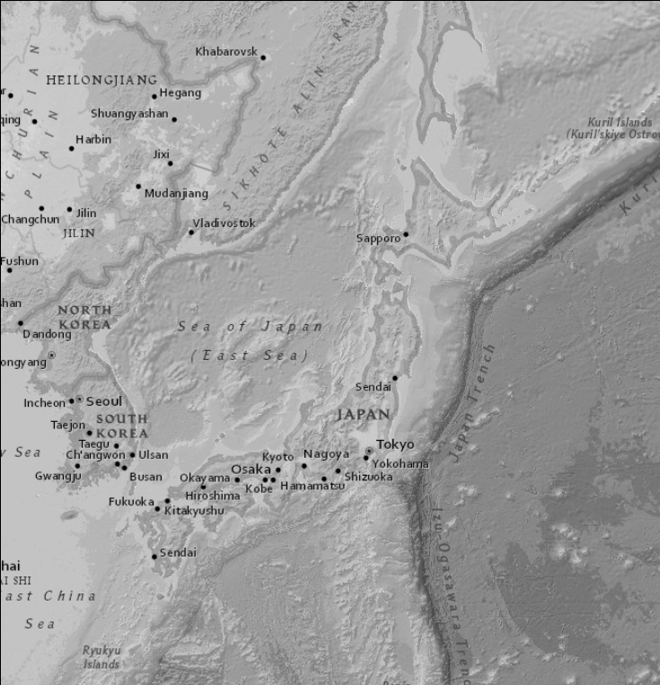

Figure 1: Figure description [10 pt Times New Roman, centered]

